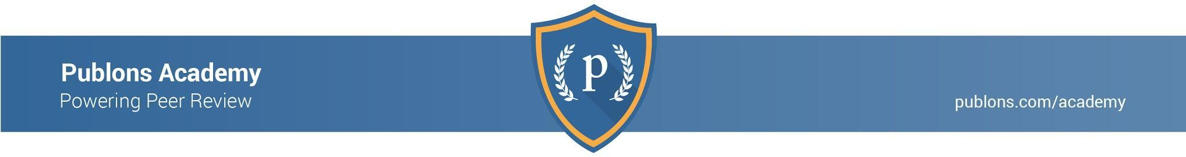
Paper title: Aim(s):

DOI: Review due date: / /
Section | Points to Ponder | Review comments and notes
Abstract, title and references | - Is the aim clear?  - Is it clear what the study found and how they did it?  - Is the title informative and relevant?  - Are the references:  - Relevant?  - Recent?  - Referenced correctly?  - Are appropriate key studies included?
Introduction/  background | - Is it clear what is already known about this topic?  - Is the research question clearly outlined?  - Is the research question justified given what is already known about the topic?
Methods | - Is the process of subject selection clear?  - Are the variables defined and measured appropriately?  - Are the study methods valid and reliable?  - Is there enough detail in order to replicate the study?
Results | - Is the data presented in an appropriate way?  - Tables and figures relevant and clearly presented?  - Appropriate units, rounding, and number of decimals?  - Titles, columns, and rows labelled correctly and clearly?  - Categories grouped appropriately?  - Does the text in the results add to the data or is it repetitive?  - Are you clear about what is a statistically significant result?  - Are you clear about what is a practically meaningful result?
Discussion and Conclusions | - Are the results discussed from multiple angles and placed into context without being overinterpreted?  - Do the conclusions answer the aims of the study?  - Are the conclusions supported by references or results?  - Are the limitations of the study fatal or are they  opportunities to inform future research?
Overall | - Was the study design appropriate to answer the aim?  - What did this study add to what was already known on this topic?  - What were the major flaws of this article?  - Is the article consistent within itself?

Structure your comments into a full review:

Overall statement or summary of the article and its findings in your own words
Overall strengths of the article and what impact it might have in your field
Specific comments on weaknesses of the article and what could be done to improve it | Major points in the article which needs clarification, refinement, reanalysis, rewrites and/or additional information and suggestions for what could be done to improve the article.  Minor points like figures/tables not being mentioned in the text, a missing reference, typos, and other inconsistencies.

